**Our Projects**

Thermal Power plant / Grid Substations

Hydroelectric Power plant / Commercial Projects

Neuclear Power Plant / Industrial Project

Solar power plant/ Power Plant

Grid Substations:

1. **400kV, 25MVAR Shunt Reactors GIS Substation**

Design, Supply, Installation, Testing, and Commissioning of 400kV GIS Substation  
25MVAR Three Phase Shunt Reactorsat Matarbari 400kV GIS Substation with Associated Supply and Services on a Turnkey basis

* *Status: Completed.*
* *Owner: Power Grid Company of Bangladesh (PGCB).*
* *Main Contractor: CCCE*
* *Area: Matarbari, Bangladesh.*
* *Works Type :2x 25MVAR 400kV Shunt Reactor, 400kV GIS Substation Electrical and Civil Construction Works.*
* *Commercial Operation Date: February 02,2025*

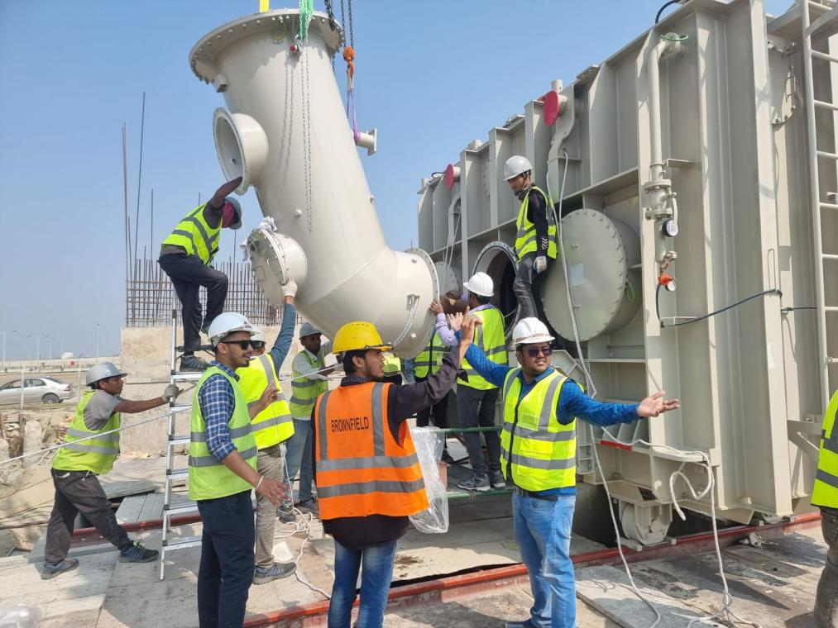

1. **132/33kV AIS Substation, Bhandaria.**

Design, Supply, Installation, Testing, and Commissioning of 132/33kV AIS Substation  
50/75MVA Three Phase Power transformer at Bhandaria 132/33kV AIS Substation with Associated Supply and Services on a Turnkey basis

* *Status: Completed.*
* *Owner: Power Grid Company of Bangladesh (PGCB).*
* *Main Contractor: CCCE*
* *Area: Bhandaria, Bangladesh.*
* *Works Type : Electrical*
* *Commercial Operation Date: January 28,2025*

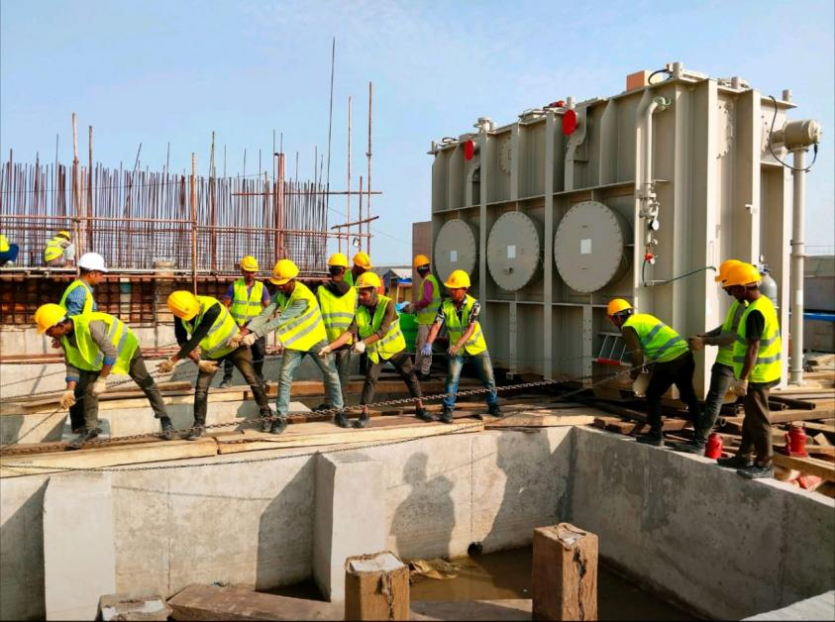

**3.132/33kV AIS Substation, Mongla.**

Design, Supply, Installation, Testing, and Commissioning of 132/33kV AIS Substation  
50/75MVA Three Phase Power transformer at Mongla 132/33kV AIS Substation with Associated Supply and Services on a Turnkey basis

* *Status: Completed.*
* *Owner: Power Grid Company of Bangladesh (PGCB).*
* *Main Contractor: CCCE*
* *Area: Mongla, Bangladesh.*
* *Works Type : Electrical & Civil Construction and Renovationand Updgradation works.*
* *Commercial Operation Date: March 09,2025*

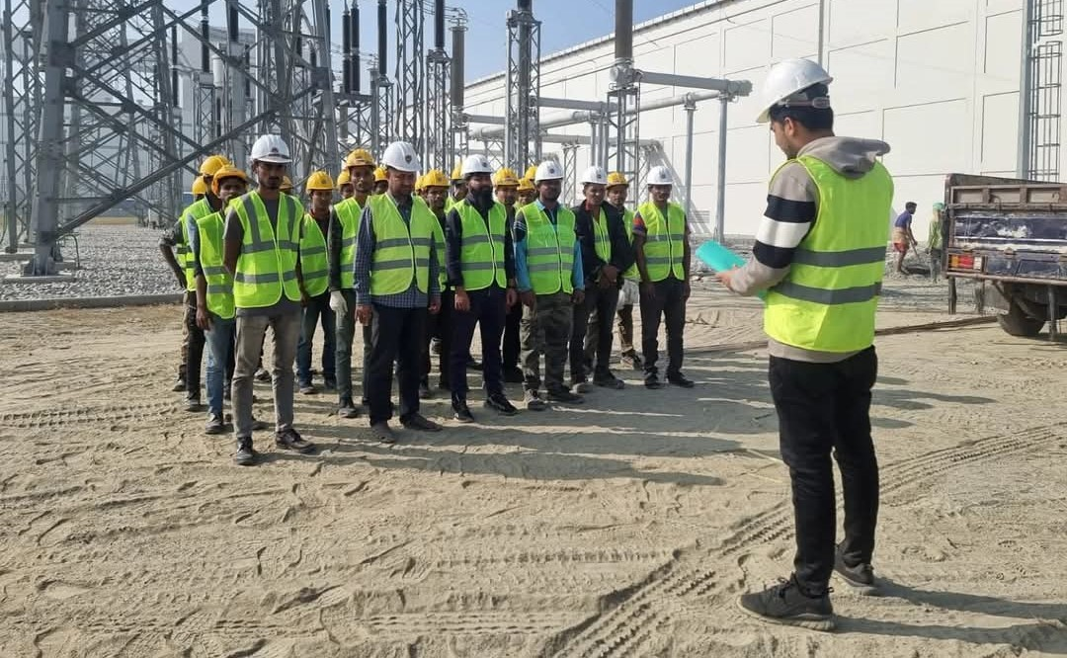

**4.132/33kV AIS Substation, Gopalganj.**

Design, Supply, Installation, Testing, and Commissioning of 132/33kV AIS Substation  
80/120MVA Three Phase Power transformer at Gopalgonj 132/33kV AIS Substation with Associated Supply and Services on a Turnkey basis

* *Status: Running*
* *Owner: Power Grid Company of Bangladesh (PGCB).*
* *Main Contractor: CCCE*
* *Works Type : Electrical & Civil Construction and Renovation works.*
* *Area: Gopalgonj, Bangladesh.*

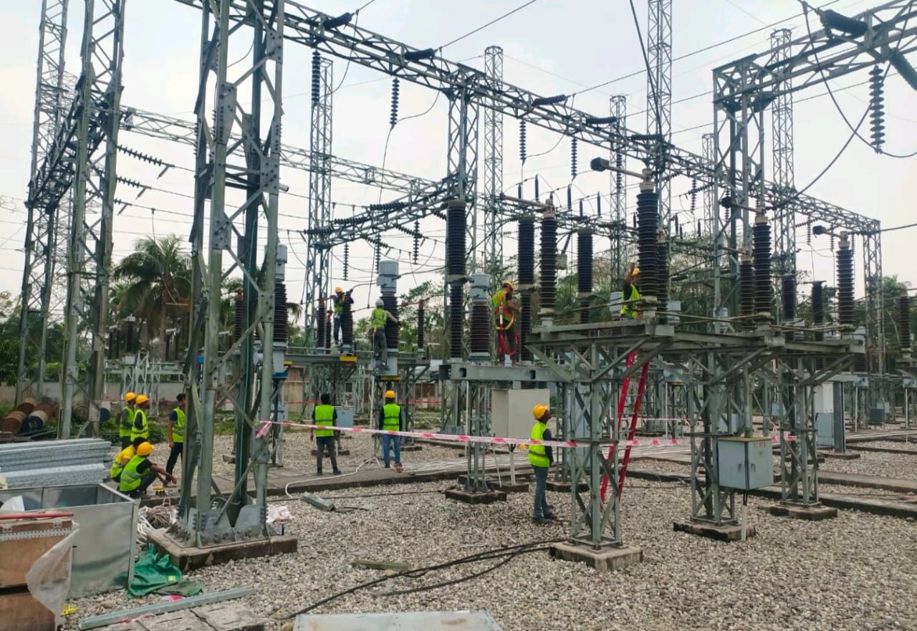

**Commercial Projects:**

**1.United Healthcare, United City,**

**United Group**

* *Status: Completed*
* *Owner: United*
* *Works Type : Electrical LV Switch-gear equipment, MDB, DB etc.*
* *Area: Madani Avenue, Badda , Dhaka*

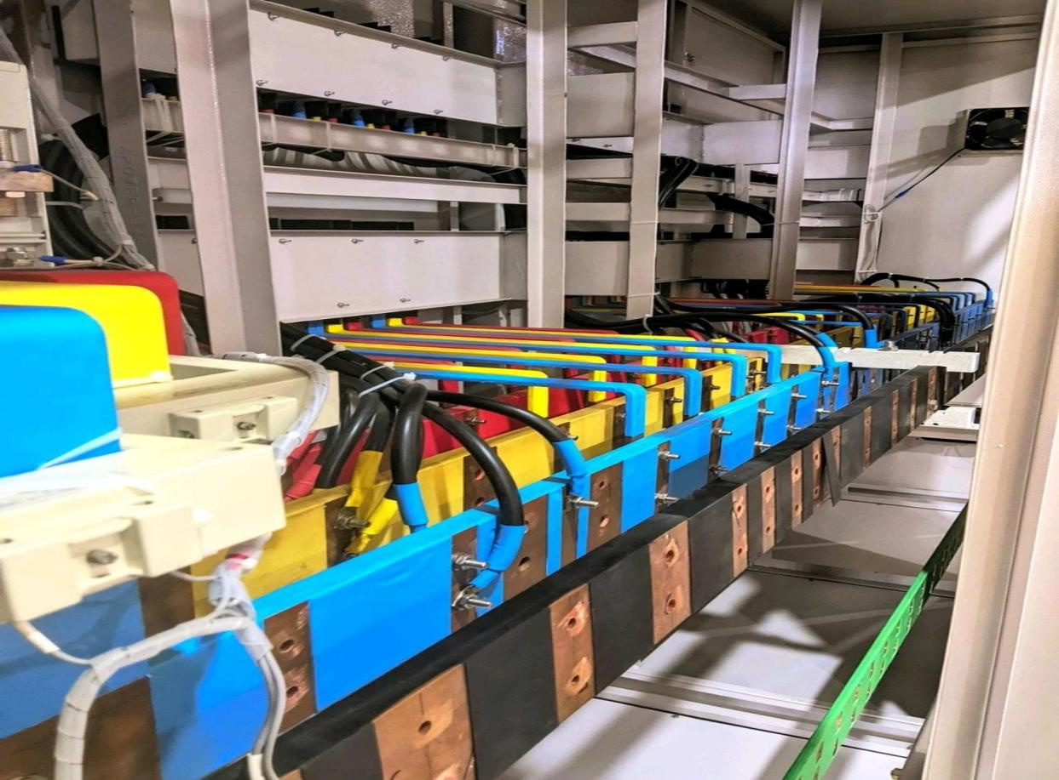

1. **IPCO Developments BD. Ltd, Airport.**

**United Group**

* *Status: Completed*
* *Owner: United*
* *Works Type : Electrical LV Equipment's.*
* *Area: Airport Road, Dhaka*

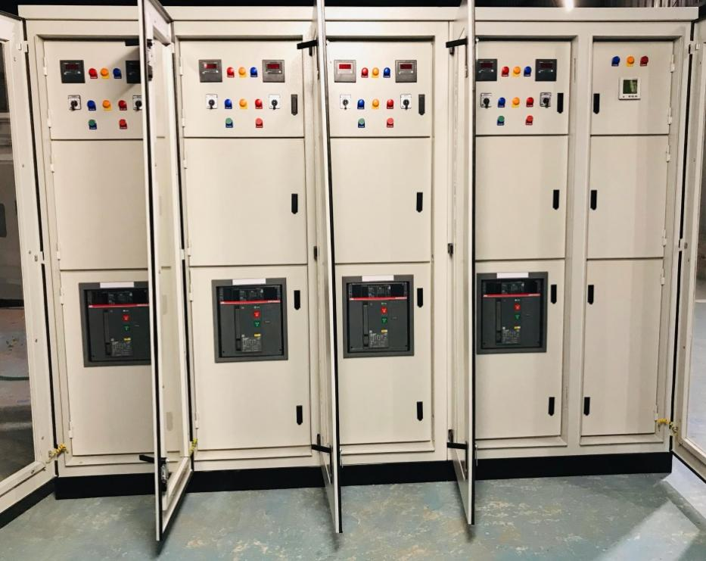

1. **Gulshan Center Point (GCP), Gulshan 2.**

**United Group**

* *Status: Completed*
* *Owner: United*
* *Works Type : Electrical LV Switch-gear, Bus-Bar Trunking, Substation Servicing.*
* *Area: Madani Avenue, Badda , Dhaka*

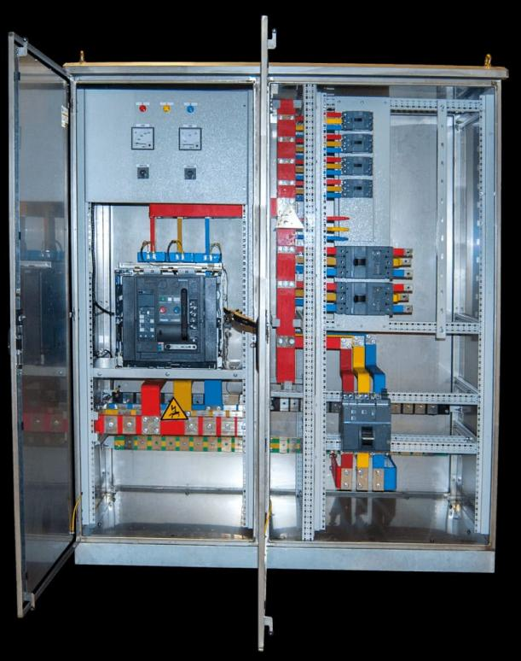

**4.Shiamto Shombhar, BGB Headquaters, Pilkhana, Dhaka.**

* *Status: Completed*
* *Owner: Shimanto Shombhar Shopping Complex*
* *Works Type : Supply , Installation Testing & Commissioning of HV Switch-gear and Substation works.*
* *Area: Pilkhana, Dhaka.*

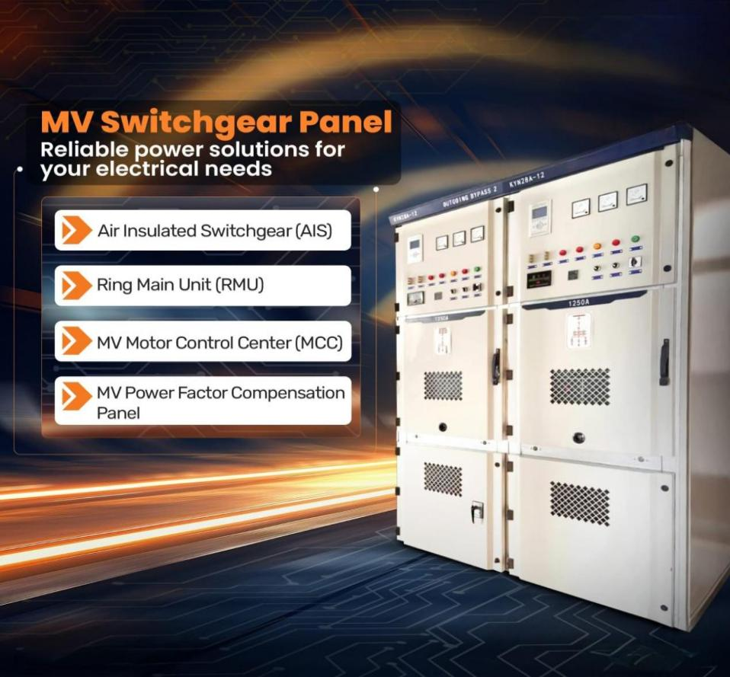

5.East West Medical College Hospital.

* *Status: Completed*
* *Owner: East West Medical College Hospital:*
* *Works Type : 2000kvA Substation, 11kV Automatic Voltage Regulator, Generator*
* *Area: Narayanganj*

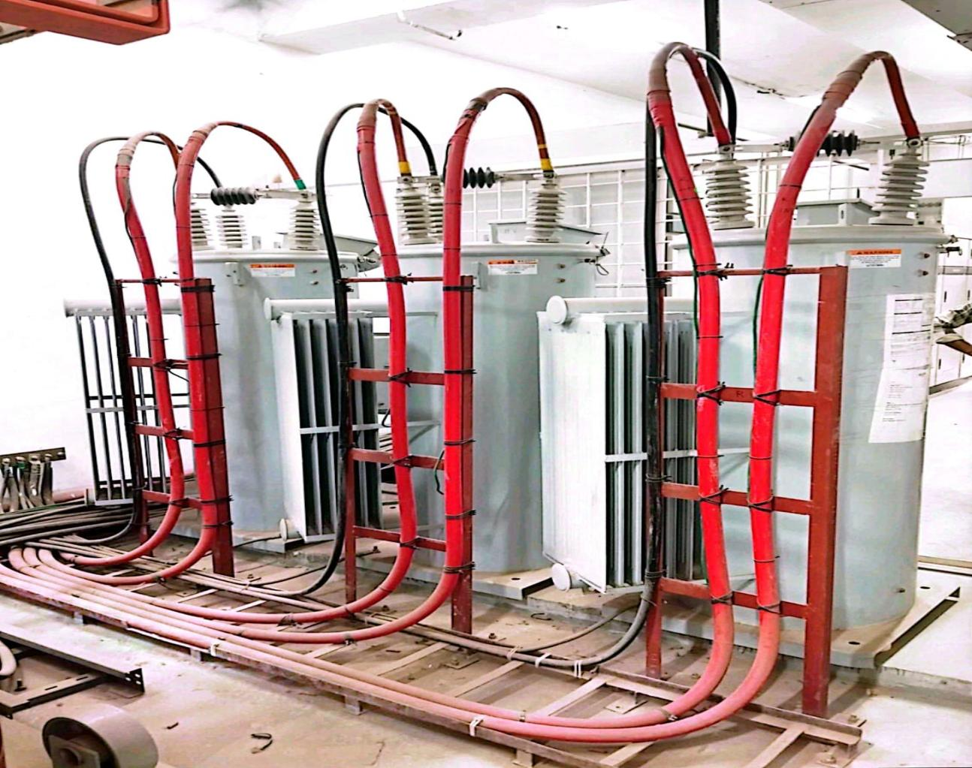

**Industrial Projects:**

1. **BEOL,Rupshi, Narayanganj**

* *Status: Completed*
* *Owner: Bangladesh Edible Oil Limited(BEOL).*
* *Works Type : Electrical (5MW/6.5MVA 33/11kV Substation with Transmission line)*
* *Area: Narayanganj*

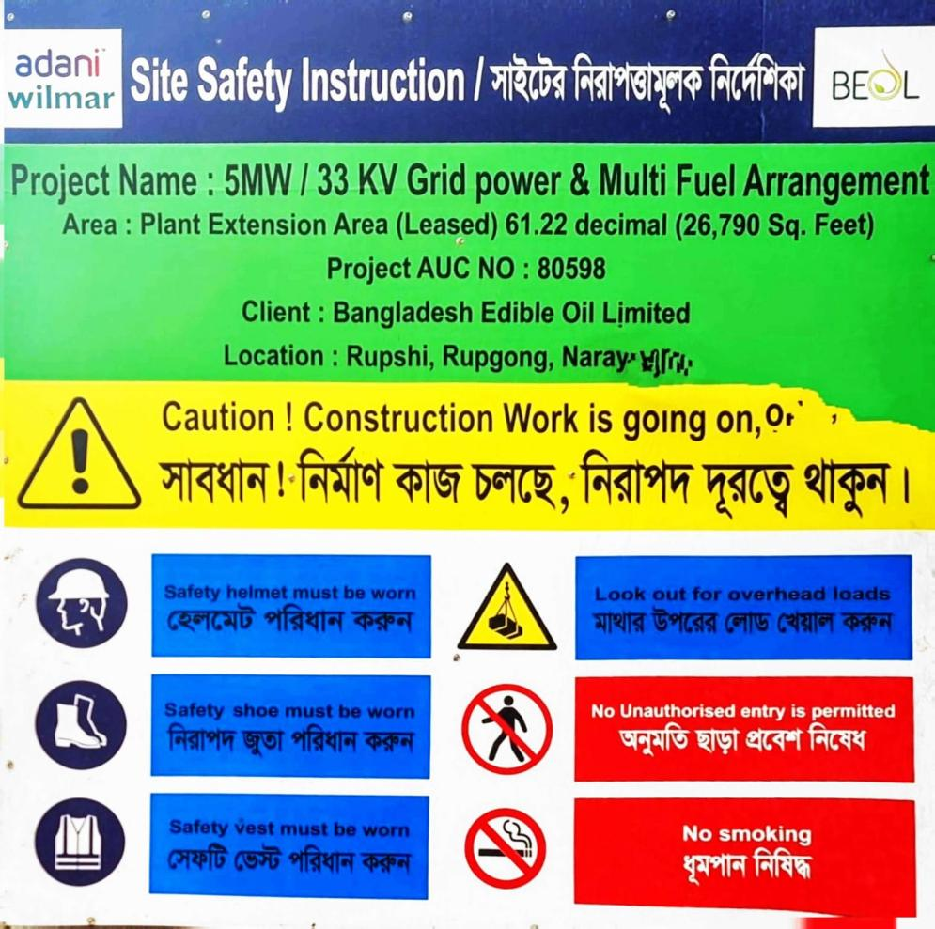

1. **Marcer Knit Composite, Asulia, Savar, Dhaka**

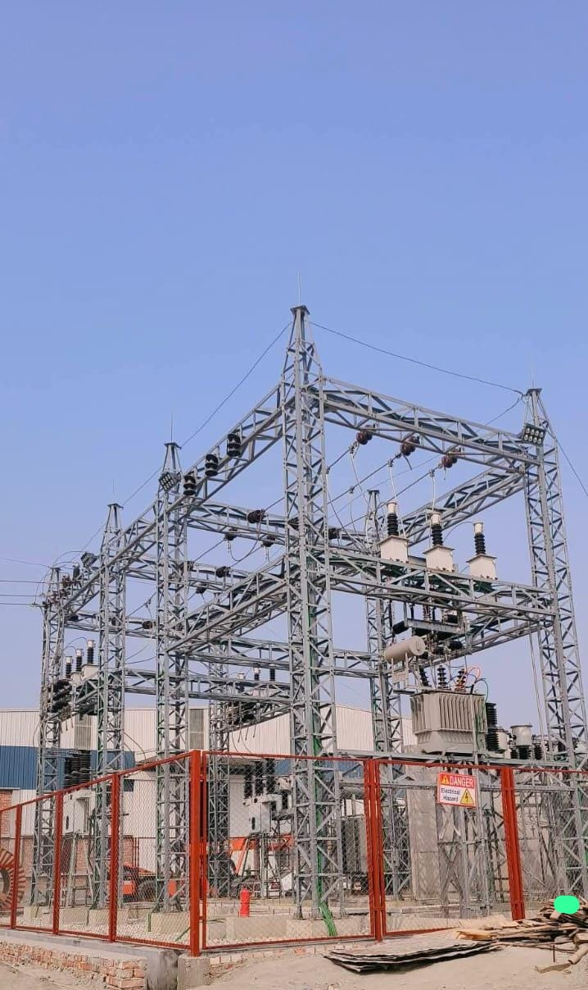

* *Status: Completed*
* *Owner: Marcer Knit Composite*
* *Works Type : Electrical (5MVA 33/11kV Substation ), Grid Synchronization*
* *Area: Savar.*

1. **Metro Knit Composite, Asulia, Savar, Dhaka**



* *Status: Completed*
* *Owner: Metro Knit Composite.*
* *Works Type : Electrical (5MVA 33/11kV Substation ), Grid Synchronization*
* *Area: Savar.*

1. **Ahmed Wood Crafts (PVT.) Ltd, Saidpur.**

* *Status: Completed*
* *Owner: Ahmed Wood Crafts(PVT.) Ltd.*
* *Works Type : 33/11kV Transmission Line Construction*
* *Area: Saidpur*

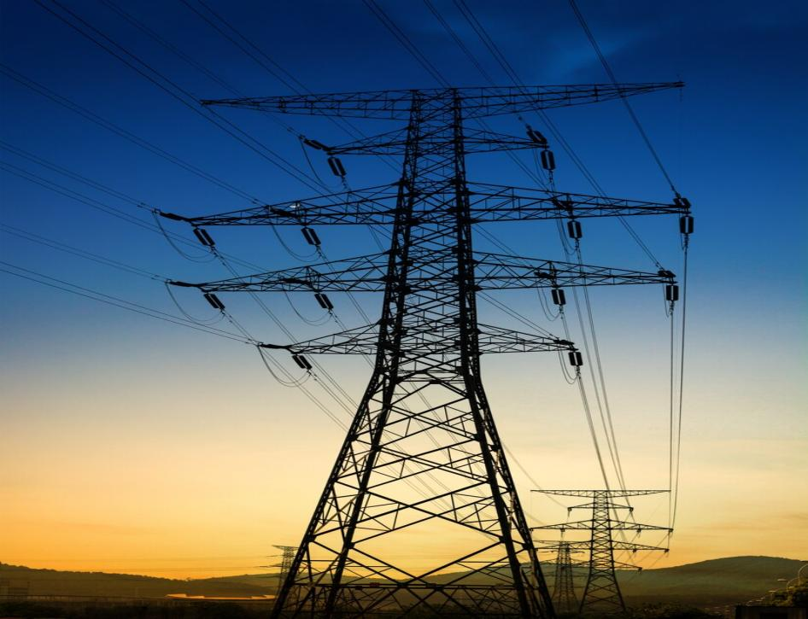

**Solar power plant/ Power Plant:**

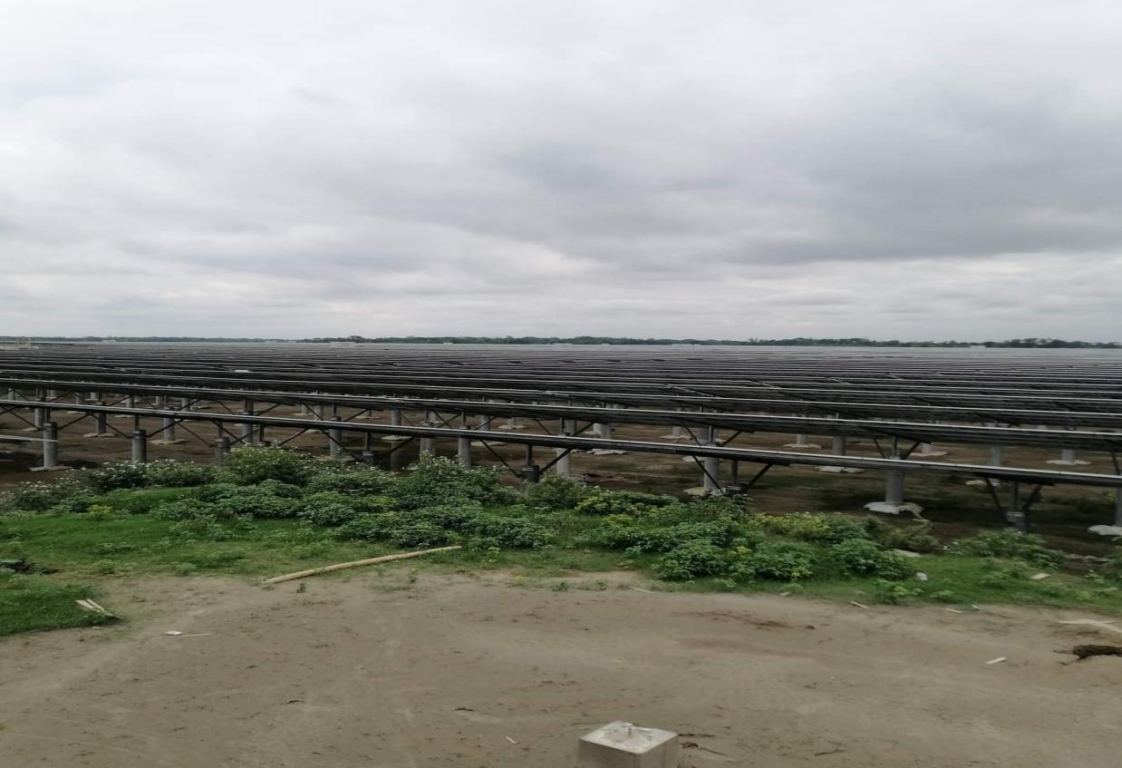

* *Status: Completed*
* *Owner: PGCB*
* *Works Type : 35MW Solar Power Plant*
* *Area: Ishwardi, Pabna*